Update the Table of Contents to see the new contents of document ⬆️

Admin Console Guide1

# Sign in to The Administrator

## Selecting the UI Language

To change the user interface language of the Admin console, click on the context menu at the upper right corner to open the settings screen:

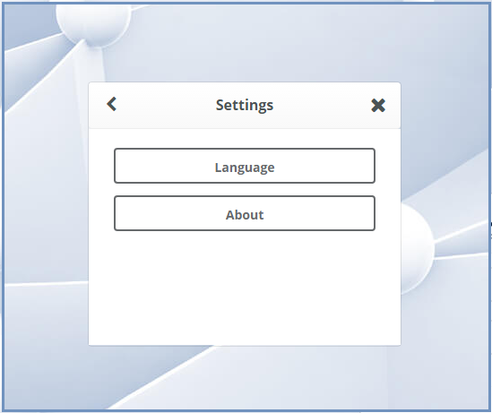

https://cdn.docsie.io/boo_6p9W3Q9hLTXBUkKnD/df673a8d-4c94-5a20-67bc-ec990fe14883selecting_the_ui_language1.png

Select the Language option

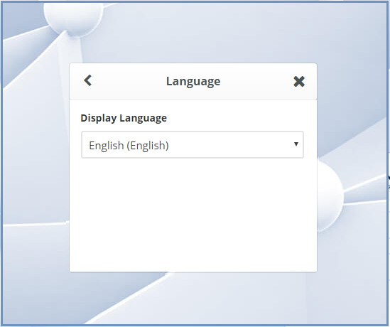

https://cdn.docsie.io/boo_6p9W3Q9hLTXBUkKnD/a9761232-ec7b-6939-b749-39e993f8827aselecting_the_ui_language2.png

Select the desired language from the list and the user interface will use the selected language.

Example using Japanese:

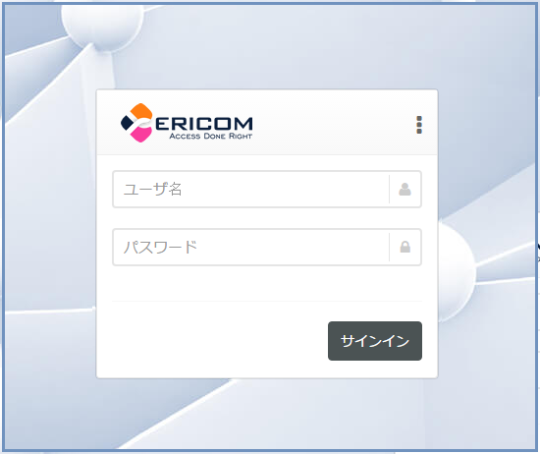

https://cdn.docsie.io/boo_6p9W3Q9hLTXBUkKnD/a8b9b72f-9b1a-d027-51dd-37610117374aselecting_the_ui_language3.png

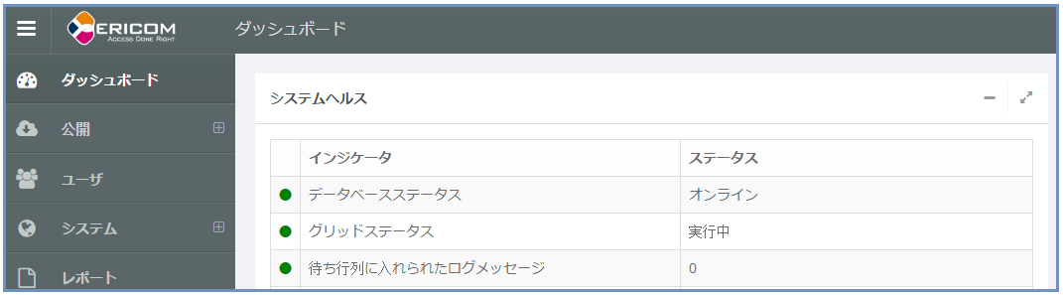

https://cdn.docsie.io/boo_6p9W3Q9hLTXBUkKnD/ea936983-53c9-bd32-11fa-8221535924aaselecting_the_ui_language4.png

Certain default objects in Ericom Connect were created in English (e.g. *All Resources* and *All Hosts* group) and will not be translated.  To change these texts to the local language, go to the object’s properties and enter the desired text in the local language.

# Using the Administration Console

## Navigation Panel

The web based administration console comprises the following panels:

### Navigation Panel

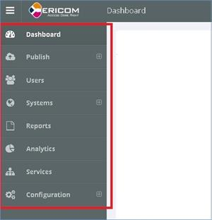

Navigation Panel

The navigation panel is located on the far left side of the console. It displays the available categories and functionalities of the administration console. Some of the categories have a small arrow on the right, which indicates that this category includes sub sections. Pressing the category name will expand and display the sub sections. Pressing it again will close the sub sections list. On monitors with lower vertical resolution a scroll bar will appear.

## Primary Panel

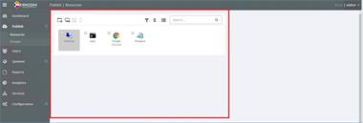

Primary Panel

This panel is located in the middle area of the console. It displays the high level information and configuration related to the selected category. For certain categories, such as "Dashboard", the "Primary" panel will be wider, and for others, such as "Resources" the "Primary" panel will include a "Details" panel as well.

## Details Panel

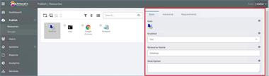

Details Panel

This panel will be displayed on the right side of the console for certain categories. When displayed, this panel includes additional information and configuration functions for items selected in the "Primary" panel.

## Expanding and Collapsing List Objects

Certain objects in the administration console may be expanded or collapsed by clicking a "+/-" icon. Such objects are usually lists of additional objects of the same category.



https://cdn.docsie.io/boo_6p9W3Q9hLTXBUkKnD/049166a4-2cf4-5b73-9288-37867229215aexpand_oject.png

"Collapsed" - Currently collapsed and contained objects are hidden. Click the icon to enter "Expanded" mode to view additional objects contained within.



https://cdn.docsie.io/boo_6p9W3Q9hLTXBUkKnD/c86a7546-4c44-58dd-50b7-7be50f062b41collapse_object.png

"Expanded" - Currently expanded to display all contained objects. Click the icon to enter "Collapsed" mode to hide contained objects.

## Tooltips



https://cdn.docsie.io/boo_6p9W3Q9hLTXBUkKnD/c5467940-2dc1-662c-f6eb-977e40122eaaTooltip_1.png

Hovering the mouse over the info icon will display a tooltip message explaining the purpose of the feature, or detailed explanation about the setting, e.g.,:

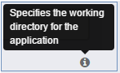

https://cdn.docsie.io/boo_6p9W3Q9hLTXBUkKnD/43e2aaaa-cb8f-c8da-f0bf-7cc5b3995926Tooltip_2.png

## Toggling Inheritance

Each setting may inherit a value from a different layer.  The "Toggle Inheritance" button allows the administrator to select an inherited value or a configured "local" value.  Refer to the "Deployment Guide" | "Inheritance Hierarchy" section for more details on how inheritance operates within Connect. Example of an Inheritance button:

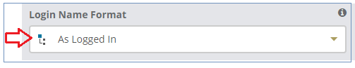

https://cdn.docsie.io/boo_6p9W3Q9hLTXBUkKnD/61be8576-619a-3c5e-da65-aec9e94779f8Inheritance_1.png

**Specify a Local Value**

Configure the target setting and configure the "Inheritance" button to use the local value:



https://cdn.docsie.io/boo_6p9W3Q9hLTXBUkKnD/e3f58686-baf2-ddb9-5411-05708dc8ec54Inheritance_2.png

The tooltip will confirm that the local value is used:

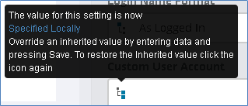

https://cdn.docsie.io/boo_6p9W3Q9hLTXBUkKnD/f03c0995-6eaa-b081-858d-a4f816e669b3Inheritance_3.png

**Use the Inherited Value**

Configure the "Inheritance" button to use the inherited value:



https://cdn.docsie.io/boo_6p9W3Q9hLTXBUkKnD/b9006293-6161-e9fe-7f47-e2ec798e4335Inheritance_4.png

The tooltip will confirm that the inherited value is used:

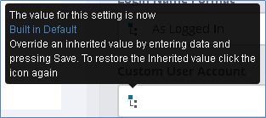

https://cdn.docsie.io/boo_6p9W3Q9hLTXBUkKnD/e40e290f-3866-8e0e-36e9-2ac39295624bInheritance_5.png

## Navigation Panel

The web based administration console comprises the following panels:

### Navigation Panel



Navigation Panel

The navigation panel is located on the far left side of the console. It displays the available categories and functionalities of the administration console. Some of the categories have a small arrow on the right, which indicates that this category includes sub sections. Pressing the category name will expand and display the sub sections. Pressing it again will close the sub sections list. On monitors with lower vertical resolution a scroll bar will appear.

## Primary Panel



Primary Panel

This panel is located in the middle area of the console. It displays the high level information and configuration related to the selected category. For certain categories, such as "Dashboard", the "Primary" panel will be wider, and for others, such as "Resources" the "Primary" panel will include a "Details" panel as well.

## Details Panel



Details Panel

This panel will be displayed on the right side of the console for certain categories. When displayed, this panel includes additional information and configuration functions for items selected in the "Primary" panel.

## Expanding and Collapsing List Objects

Certain objects in the administration console may be expanded or collapsed by clicking a "+/-" icon. Such objects are usually lists of additional objects of the same category.



https://cdn.docsie.io/boo_6p9W3Q9hLTXBUkKnD/049166a4-2cf4-5b73-9288-37867229215aexpand_oject.png

"Collapsed" - Currently collapsed and contained objects are hidden. Click the icon to enter "Expanded" mode to view additional objects contained within.



https://cdn.docsie.io/boo_6p9W3Q9hLTXBUkKnD/c86a7546-4c44-58dd-50b7-7be50f062b41collapse_object.png

"Expanded" - Currently expanded to display all contained objects. Click the icon to enter "Collapsed" mode to hide contained objects.

## Tooltips



https://cdn.docsie.io/boo_6p9W3Q9hLTXBUkKnD/c5467940-2dc1-662c-f6eb-977e40122eaaTooltip_1.png

Hovering the mouse over the info icon will display a tooltip message explaining the purpose of the feature, or detailed explanation about the setting, e.g.,:



https://cdn.docsie.io/boo_6p9W3Q9hLTXBUkKnD/43e2aaaa-cb8f-c8da-f0bf-7cc5b3995926Tooltip_2.png

## Toggling Inheritance

Each setting may inherit a value from a different layer.  The "Toggle Inheritance" button allows the administrator to select an inherited value or a configured "local" value.  Refer to the "Deployment Guide" | "Inheritance Hierarchy" section for more details on how inheritance operates within Connect. Example of an Inheritance button:



https://cdn.docsie.io/boo_6p9W3Q9hLTXBUkKnD/61be8576-619a-3c5e-da65-aec9e94779f8Inheritance_1.png

**Specify a Local Value**

Configure the target setting and configure the "Inheritance" button to use the local value:



https://cdn.docsie.io/boo_6p9W3Q9hLTXBUkKnD/e3f58686-baf2-ddb9-5411-05708dc8ec54Inheritance_2.png

The tooltip will confirm that the local value is used:



https://cdn.docsie.io/boo_6p9W3Q9hLTXBUkKnD/f03c0995-6eaa-b081-858d-a4f816e669b3Inheritance_3.png

**Use the Inherited Value**

Configure the "Inheritance" button to use the inherited value:



https://cdn.docsie.io/boo_6p9W3Q9hLTXBUkKnD/b9006293-6161-e9fe-7f47-e2ec798e4335Inheritance_4.png

The tooltip will confirm that the inherited value is used: **Navigation Panel**

The web based administration console comprises the following panels:

### Navigation Panel



Navigation Panel

The navigation panel is located on the far left side of the console. It displays the available categories and functionalities of the administration console. Some of the categories have a small arrow on the right, which indicates that this category includes sub sections. Pressing the category name will expand and display the sub sections. Pressing it again will close the sub sections list. On monitors with lower vertical resolution a scroll bar will appear.

## Primary Panel



Primary Panel

This panel is located in the middle area of the console. It displays the high level information and configuration related to the selected category. For certain categories, such as "Dashboard", the "Primary" panel will be wider, and for others, such as "Resources" the "Primary" panel will include a "Details" panel as well.

## Details Panel



Details Panel

This panel will be displayed on the right side of the console for certain categories. When displayed, this panel includes additional information and configuration functions for items selected in the "Primary" panel.

## Expanding and Collapsing List Objects

Certain objects in the administration console may be expanded or collapsed by clicking a "+/-" icon. Such objects are usually lists of additional objects of the same category.



https://cdn.docsie.io/boo_6p9W3Q9hLTXBUkKnD/049166a4-2cf4-5b73-9288-37867229215aexpand_oject.png

"Collapsed" - Currently collapsed and contained objects are hidden. Click the icon to enter "Expanded" mode to view additional objects contained within.



https://cdn.docsie.io/boo_6p9W3Q9hLTXBUkKnD/c86a7546-4c44-58dd-50b7-7be50f062b41collapse_object.png

"Expanded" - Currently expanded to display all contained objects. Click the icon to enter "Collapsed" mode to hide contained objects.

## Tooltips



https://cdn.docsie.io/boo_6p9W3Q9hLTXBUkKnD/c5467940-2dc1-662c-f6eb-977e40122eaaTooltip_1.png

Hovering the mouse over the info icon will display a tooltip message explaining the purpose of the feature, or detailed explanation about the setting, e.g.,:



https://cdn.docsie.io/boo_6p9W3Q9hLTXBUkKnD/43e2aaaa-cb8f-c8da-f0bf-7cc5b3995926Tooltip_2.png

## Toggling Inheritance

Each setting may inherit a value from a different layer.  The "Toggle Inheritance" button allows the administrator to select an inherited value or a configured "local" value.  Refer to the "Deployment Guide" | "Inheritance Hierarchy" section for more details on how inheritance operates within Connect. Example of an Inheritance button:



https://cdn.docsie.io/boo_6p9W3Q9hLTXBUkKnD/61be8576-619a-3c5e-da65-aec9e94779f8Inheritance_1.png

**Specify a Local Value**

Configure the target setting and configure the "Inheritance" button to use the local value:



https://cdn.docsie.io/boo_6p9W3Q9hLTXBUkKnD/e3f58686-baf2-ddb9-5411-05708dc8ec54Inheritance_2.png

The tooltip will confirm that the local value is used:



https://cdn.docsie.io/boo_6p9W3Q9hLTXBUkKnD/f03c0995-6eaa-b081-858d-a4f816e669b3Inheritance_3.png

**Use the Inherited Value**

Configure the "Inheritance" button to use the inherited value:



https://cdn.docsie.io/boo_6p9W3Q9hLTXBUkKnD/b9006293-6161-e9fe-7f47-e2ec798e4335Inheritance_4.png

The tooltip will confirm that the inherited value is used:

# Dashboard

## System Health

This widget provides useful information related to the health of the Connect system. When there is a problem in the system, this is the first place to check for errors and warnings. The widget includes information for many types of data including:

* Database status
* Grid status
* Log Message Queue
* Database Usage
* Insufficient memory - warning only
* RemoteAgent (Windows) version status
* RemoteAgent (Linux) version status
* Active sessions (does not include non-Connect remote sessions)
* Disconnected sessions (does not include non-Connect remote sessions)
* License status
* License expiration
* Terminal Servers (count)
* Desktops (count)
* Published Applications (count)
* Tenants

To monitor the health of the Terminal (RDS) Servers and Workstations go to “Systems” | “Hosts”.

## Status Indicators

Green: Healthy – normal operation

Yellow: Warning – operational, but requires attention

Red: Need Immediate Attention – non-operational or imminent problem

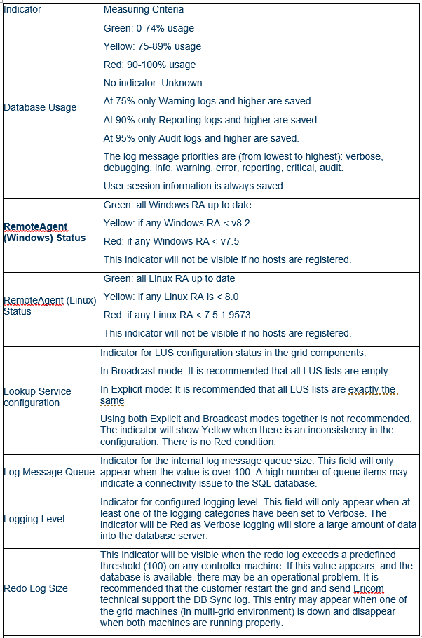

https://cdn.docsie.io/boo_6p9W3Q9hLTXBUkKnD/499a4704-fa25-1504-84eb-5f1806326fe8Status_Indicators.PNG

## Active Resource Status

Displays the following data of each resource:

* Resource name
* Active Connect Sessions (the amount of sessions for this resource initiated via Connect, does not include non-Connect RDP sessions)

Disconnected State

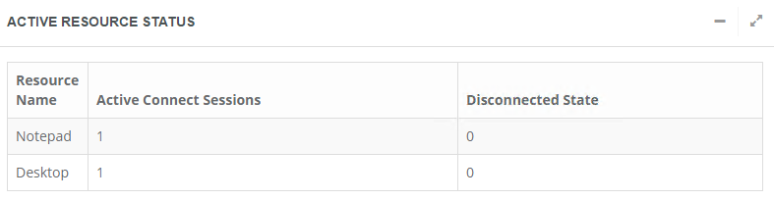

https://cdn.docsie.io/boo_6p9W3Q9hLTXBUkKnD/07c28850-44bf-8e74-8d49-e6af785155d2active_resource_status.png

## Recent Launches

Displays the following data of each session:

* Server Name
* User Name
* Principal Name
* Application
* Status
* Launch time

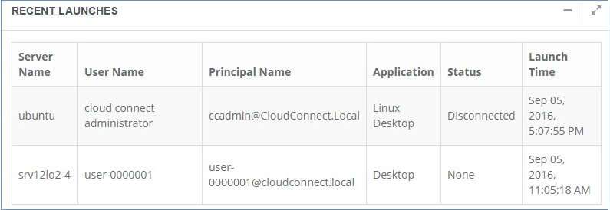

https://cdn.docsie.io/boo_6p9W3Q9hLTXBUkKnD/c99ef41b-c824-4930-3918-0d80fd49652drecent_launches.png

## Connect Status

Displays the time and date the server was started at.

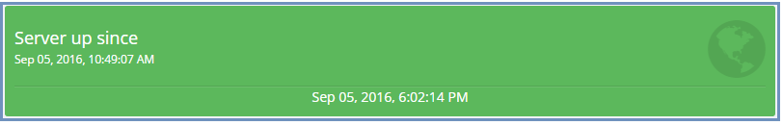

https://cdn.docsie.io/boo_6p9W3Q9hLTXBUkKnD/eb5356ed-b12d-28b5-18f7-b742edf63e91connect_status.png

## Resource Server Status

Displays the following data of each remote server and workstation:

* System Name
* CPU (percent)
* Memory
* All Sessions (includes Connect and non-Connect sessions)

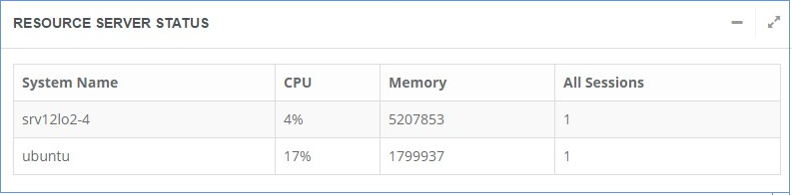

https://cdn.docsie.io/boo_6p9W3Q9hLTXBUkKnD/a70d6426-92f3-594e-f3ea-bbeadbb429d7resource_server_status.png

# Users

## Information

The Users section displays all the users that have ever logged into Connect. The "Primary" panel displays a list of the users and any respective active Portal and Connect initiated RDP sessions.



https://cdn.docsie.io/boo_6p9W3Q9hLTXBUkKnD/cac6cffc-e007-c0f4-813d-87cac050afa1users1.png

To see detailed user data, click on the user account and the associated information will be displayed in the Details panel.

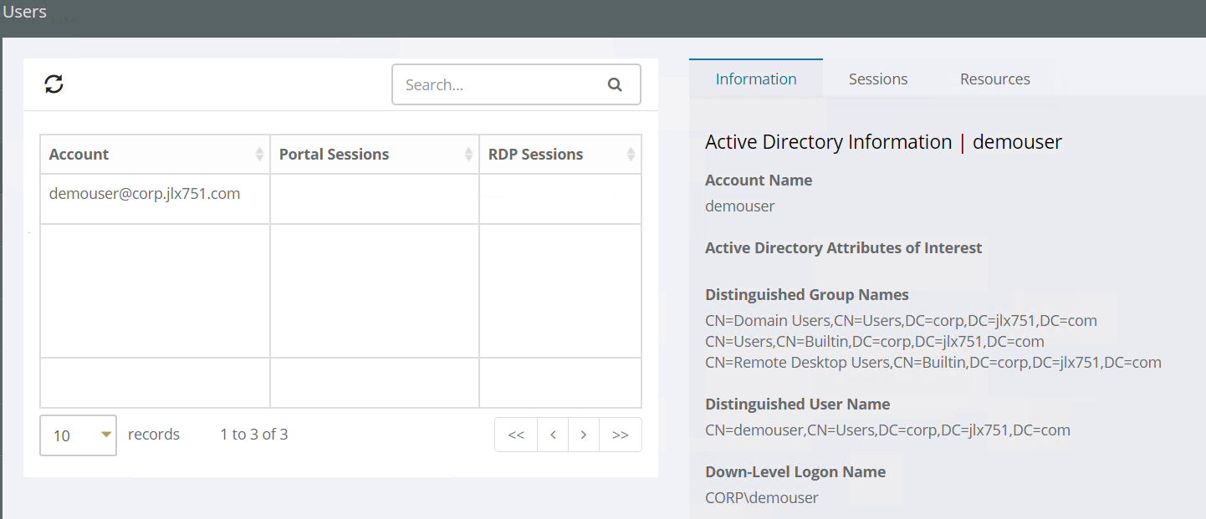

https://cdn.docsie.io/boo_6p9W3Q9hLTXBUkKnD/fa406e1e-8ee0-e4ad-ccb1-b84deef80a0fusers2.png

To manually add a user, enter the user’s FQDN prefixed with a ‘+’ symbol.  For example:



https://cdn.docsie.io/boo_6p9W3Q9hLTXBUkKnD/fdb9d39a-892e-2352-a9c2-a14f3b8207a7users3.png

The tab in the "Details" Panel that displays the following information for a selected user:

* Active Directory information – provides extensive user account details retrieved from Active Directory.

## Advanced Searches

The search text entry box allows for structure search expressions. The search can include constraints for username, hostname and rdp session status. Each type of constraint can occur at most once (so only one hostname constrant). The syntax is a space separated list of search terms. The terms can be one of the following

**Username Constraint**

User name search (the username is matched as a Connect regular expression). The following are equivalent

|  |
| --- |
| <userName> |

|  |
| --- |
| <userName> u:<userName> |

The search matches against the users login name and also the users' full name.

There are cases where you might want to see information about a user that has never done a Login into Connect. If the normal search of Connect users finds nothing, The Active Directory will be checked for this user and if present, the user will be added into Connect by using the syntax

|  |
| --- |
| Code block labellanguage+user@domain |

**Host name constraint**

Host search for hostname, host dns name, IP address. Exact match is used.

|  |
| --- |
| Code block labellanguagehost:<hostOrIp> h:<hostOrIp> |

**RDP session status**

Rdp session status. The status keywords are 'active', 'disconnected', and '*'. You can also use 'a', 'd' for 'active' and 'disconnected' respectively. * means there is an rdp session in any state

|  |
| --- |
| Code block labellanguagerdp:active rdp:a |

|  |
| --- |
| Code block labellanguager:d |

|  |
| --- |
| Code block labellanguagerdp:* (rdp session in any state) |

|  |
| --- |
| Code block labellanguager: (without a status keyword, '*' is used). |

**Application name**

The name of the application/desktop that was launched. A regular expression match is used

|  |
| --- |
| Code block labellanguageappname:<resource name> |

|  |
| --- |
| Code block labellanguagea:<resource name> |

**Example Searches**

|  |  |
| --- | --- |
| user:michael | search for the user with 'michael' as part of the name |
| michael | same as the above |
| "john galt" | to match a user name with an embedded space, the name must be quoted |
| u:"john galt" | to match a user name with an embedded space, the name must be quoted |
| ^m | search for users whose names start with the letter 'm' |
| host:126.1.2.3 | find users with rdp sessions on the specified host |
| h:rdpserver1 | find users with rdp sessions on the specified host |
| appname:microsoft | Any application with 'microsoft' as part of the name |
| a:^excel$ | The application with the exact name of 'excel' |
| michael | find all users with 'michael' as part of the name with currently |
| r:connected | connected rdp sessions |
| michael r: | find all users with 'michael as part of the name with either connected or disconnected rdp sessions |
| michael daniel | this is not allowed because there are two separate constraint for the username |

## Sessions

The tab in the "Details" Panel that consists of two sections: End User Session Information and Remote Session Information.

The **End User Session Information** section displays the following details for each session launched by a selected user:

* End User Session Details
* ESG Information
* Client Address
* Portal Information

The **Remote Session Information** section displays the active sessions for a selected user and available operations that may be applied on each session. To execute an action on an active session, select the desired session and click on the action.  Available actions are:

* Log off
* Disconnect
* Reset
* Send Message
* Shadow (Control and View options)

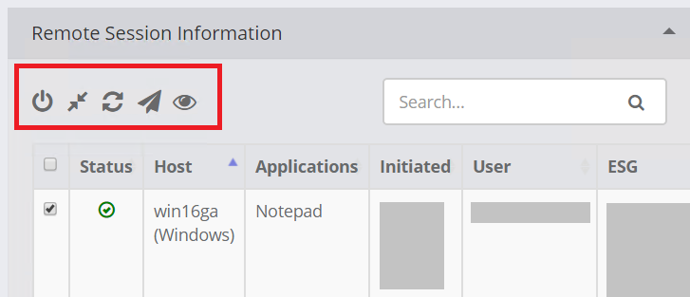

https://cdn.docsie.io/boo_6p9W3Q9hLTXBUkKnD/2a81d615-8985-7b2c-21f8-6a75c9ce250dusers_sesions1.png

**Session Shadow** uses Microsoft’s built in technology to provide the shadowing technology while using HTML5 for the administrator to view the end-user’s session. When the administrator shadows a session, credentials to shadow the user’s session is required (e.g. local administrator rights on the user’s workstation). If using a domain account, enter the domain prefix in the username or the FQDN.

As the admin session opens in a new browser tab, the browser’s pop-up blocker must be disabled for the shadow session to a launch.



https://cdn.docsie.io/boo_6p9W3Q9hLTXBUkKnD/7d8251cd-583b-9bd7-e60e-3f6789394649users_sesions2.png

Session shadow relies on Remote Desktop Session Host (RDSH) to operate and RDS CALs may be required. When shadowing a session on an RDSH host, the admin session will be launched from the same system. When shadowing a session on a workstation or VDI instance, the admin session will be launched from a randomly chosen RDSH system. If no RDSH systems are available, the shadow function will fail.

## Resources

The tab in the Details panel that displays all assigned applications for the selected user. Click on a resource to start a launch analysis for the resource.

## Launch Analysis

Traces the entire connection process of the connection from the end-user selection to the resource launch. This tool is very helpful for troubleshooting connectivity issues.

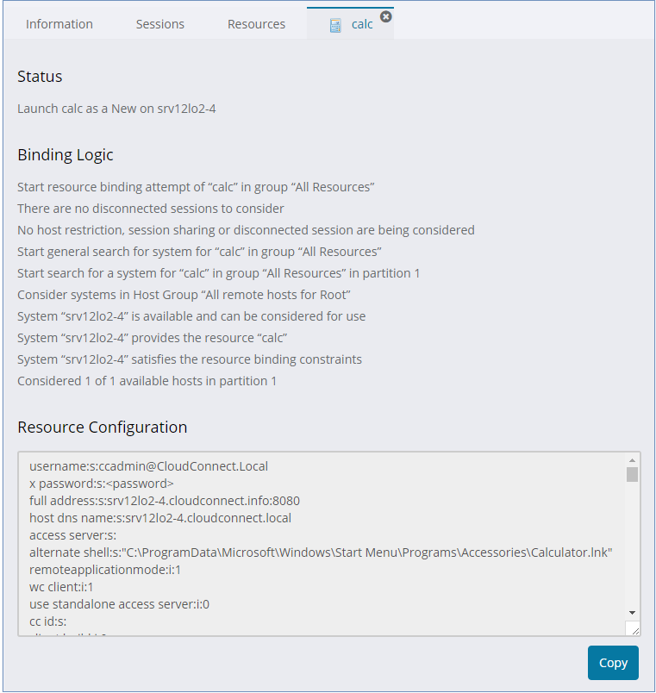

https://cdn.docsie.io/boo_6p9W3Q9hLTXBUkKnD/85434259-12a1-c0eb-af03-42899aed192eusers_launch_analysis1.png

The Launch Analysis may be simulated using different Ericom Connect portal types. To set the desired portal type, go to “Configuration” | “Settings” | “Secondary Settings tab” | Launch Analysis Portal Type (or for Tenant users: “Tenant” | “Settings” | “Settings tab” | Launch Analysis Portal Type):

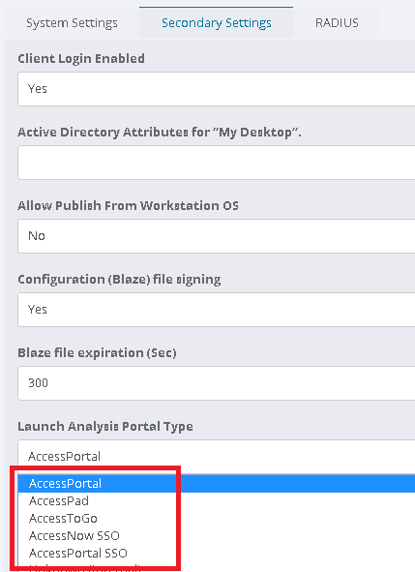

https://cdn.docsie.io/boo_6p9W3Q9hLTXBUkKnD/363a6752-5157-f52e-37f2-66fd3335a783users_launch_analysis2.png

## Settings

Use this section to configure when and from where a specific user is allowed to login.

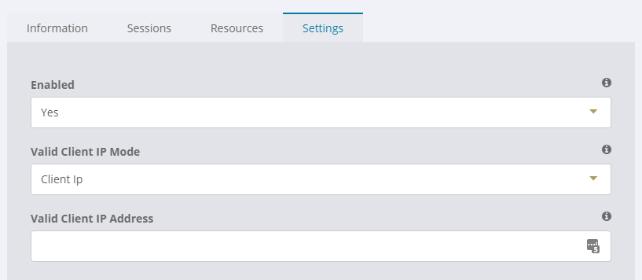

https://cdn.docsie.io/boo_6p9W3Q9hLTXBUkKnD/6fa60b57-f2d3-cdf3-982c-a9fc095ff9a1Clipboard01.png

|  |  |
| --- | --- |
| Enabled: | When 'true', the user is allowed to login |
| Valid Client IP Mode: | Controls whether or not the X-Forwarded-For header should be considered while checking for a valid client IP address. |
| Valid Client IP Addresses: | A comma separated list of acceptable client ip addresses from which the user may login. |

* 1.2.3.4 - a single IP or IPv6 address
* 1.2.* - an IPv4 style address ending in .* - this is a wildcard
* 1.2.3.3-1.2.3.34 - a range of IPv4 addresses on the same subnet

# Reports

## Categories

The "Reports" section is used to generate reports based on internally stored data. This is a powerful feature that is used to monitor any Connect service activity on a detailed level.

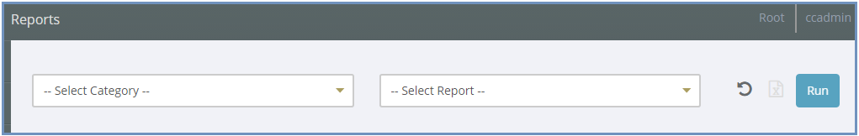

https://cdn.docsie.io/boo_6p9W3Q9hLTXBUkKnD/0a1c1f75-219d-e717-9c84-7b4fa1221d1freports1.png

“Select Category” – high level areas to sort by.

“Select Report” – detailed areas based on the selected "Category". The available options will vary based on the selected "Category".

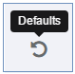

https://cdn.docsie.io/boo_6p9W3Q9hLTXBUkKnD/e4aaf87e-4040-404a-b37d-612c873f44d1reports2.png

“Defaults” button – resets all fields back to the default value.

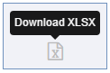

https://cdn.docsie.io/boo_6p9W3Q9hLTXBUkKnD/95f32283-6f37-7055-6e3d-f394fc1b8da0reports3.png

Download XLSX” - saves the report output data into a CSV formatted file.

“Run” button – generate a new report based on the configured parameters.  The output will always be sorted by “Timestamp” by default.  Click on one column tab to use it as the sort criteria (e.g.,”Priority”).

 “Filters" – used to refine required information to be displayed in the custom report.  Available “Filter” options will vary based on the combination of the “Category” and “Report” selected.

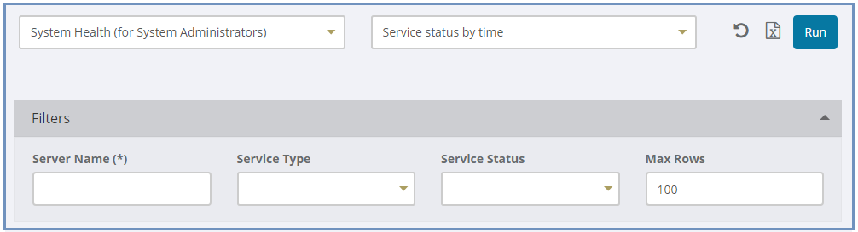

https://cdn.docsie.io/boo_6p9W3Q9hLTXBUkKnD/2b74d2f1-30dd-3bc0-729e-aad87b73a0c2reports4.png

“Results” – displays the output of data based on the configured “Category”, “Report”, and “Filters”.

Categories

### System Health (for System Administrators)

* Errors – displays general system errors
* Failed Logins – failed logins to the system with username, timestamp, Accessed URL, x-forwarded-for value, and source user address. Starting in 9.1.1, this also includes failed logins via RADIUS.
* Concurrent License Usage by Month – maximum number of unique concurrent users that launched an active session, counted by month.This report shows data for completed months.  For example, to see the usage in August, run the report on September 1st or later.
* Named User License Usage by Month – total number of unique Named users that have launched an active session, counted by month.
* License Usage – license count
* Service Status by Time – service status list

### System Health (for Tenant Administrators)

* Errors – displays general errors related to the tenant
* Launch Request Expiration - This report shows when a resources binding was successful, but no corresponding RDP session was detected. The time, user, application name, group name, and server address are displayed. The reason cannot be detected, but if there are many occurrences of an error on the same host it is a sign of a problem on that host.

### Resource Binding

* Resource Binding Failures
* Resource Binding Results
* Resource Binding by Host
* Resource Binding Details

### Users

The reports in this category are designed to track End-user session, Remote (RDP) session, and License usage activity. Note that “User Sessions” refer to the sessions in the Ericom portals (e.g. AccessPortal). Remote Sessions are the RDP sessions.

* End users: displays user’s login count, remote session count, tenant name, and initial login time
* End users sessions: displays user session information, includes source IP, x-forwarded-for value, session end time, session end reason, client type, and client version
* Remote sessions: displays users’ remote session details, includes launched application name, server name, session end time, session end reason, and number of reconnects and disconnects.
* Remote sessions (By Day)
* Failed Logins: displays the failed logins, including username, time, error message, source IP, x-forwarded-for value, and client-accessed URL. Starting in 9.1.1, this also includes failed logins via RADIUS.Session Operations: tracks administrative actions on user sessions: log off, Disconnect, Reset, Send Message and Session Shadowing

### Applications

In this category the following reports are available to track published resource launches:

* Top applications – Displays all applications that have been launched and ranks them with the most popular at the top.
* Top applications for day
* Top applications for week
* Top applications for month
* Top applications for year
* Top applications count by day of week

### Systems

In this category the following reports are available for Connect Servers monitoring (information is filtered and displayed based on server name):

* Launches per Server: number of launches on each remote server host
* Server Log Messages: displays various technical data from the logs
* Server Log Messages for System Administrators

Maintenance

In this category the following reports track database characteristics:

* Table sizes: displays all database tables and their capacity usage
* Database Information: SQL server version, edition, server name, database name, maximum size, and the current database size

Technical Support

In this category the following reports are available for tracking various log types:

* All Log Messages (sysadmin)
* Errors (sysadmin)
* All Log Messages (tenant)
* Message Types

ESG Session Log